Tab 6
ITA0601
MACHINE LEARNING

EXP 16
Compare different types Classification Algorithms and evaluate their performance

Procedure
1. Import the Iris dataset.
2. Import Decision Tree and KNN classifiers.
3. Train both models using the dataset.
4. Calculate the accuracy of each model.
5. Compare and display the results.

Dataset 1: Student Placement Prediction
This dataset contains student metrics along with their corresponding placement outcomes.

Training Data
CGPA | Aptitude Score | Communication Score | Placement
9.2 | 90 | 88 | Placed
8.8 | 85 | 82 | Placed
8.5 | 80 | 79 | Placed
7.2 | 72 | 70 | Not Placed
6.8 | 68 | 65 | Not Placed
9.0 | 92 | 90 | Placed
7.5 | 75 | 74 | Not Placed
8.6 | 84 | 81 | Placed
6.5 | 60 | 58 | Not Placed
8.9 | 88 | 86 | Placed

Target Variable: Placement (Placed / Not Placed)

New Sample for Prediction
CGPA | Aptitude Score | Communication Score
8.7 | 86 | 84

PROGRAM
import numpy as np

X=np.array([[9.2,90,88],[8.8,85,82],[8.5,80,79],[7.2,72,70],
[6.8,68,65],[9,92,90],[7.5,75,74],[8.6,84,81],[6.5,60,58],[8.9,88,86]])
y=np.array([1,1,1,0,0,1,0,1,0,1])

np.random.seed(42)
i=np.random.permutation(10)
tr,te=i[:7],i[7:]
Xtr,Xte,ytr,yte=X[tr],X[te],y[tr],y[te]

# KNN
p=[]
for x in Xte:
d=np.linalg.norm(Xtr-x,axis=1)
p.append(np.bincount(ytr[np.argsort(d)[:3]]).argmax())
knn=np.mean(np.array(p)==yte)

# Decision Tree
t=np.mean(Xtr[:,0])
p=(Xte[:,0]>=t).astype(int)
dt=np.mean(p==yte)

print("Decision Tree Accuracy:",dt)
print("KNN Accuracy:",knn)
print("KNN Prediction:", "Placed" if p[0] else "Not Placed")

OUTPUT

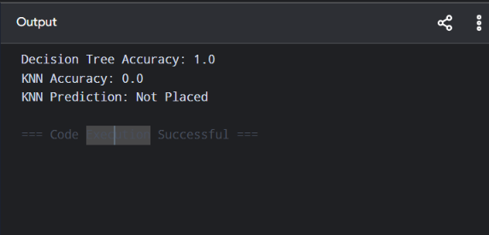

Dataset 2: Loan Approval Prediction
This dataset provides financial records and credit details used to evaluate loan approval outcomes.

Training Data
Income (₹ Lakhs) | Credit Score | Loan Amount (₹ Lakhs) | Loan Status
8 | 780 | 5 | Approved
7 | 760 | 4 | Approved
6 | 730 | 5 | Approved
4 | 620 | 8 | Rejected
3 | 590 | 9 | Rejected
9 | 810 | 4 | Approved
5 | 650 | 7 | Rejected
8 | 770 | 5 | Approved
4 | 610 | 8 | Rejected
7 | 750 | 6 | Approved

Target Variable: Loan Status (Approved / Rejected)

New Sample for Prediction
Income (₹ Lakhs) | Credit Score | Loan Amount (₹ Lakhs)
7 | 760 | 5

PROGRAM

import numpy as np

X=np.array([[8,780,5],[7,760,4],[6,730,5],[4,620,8],[3,590,9],
[9,810,4],[5,650,7],[8,770,5],[4,610,8],[7,750,6]])
y=np.array([1,1,1,0,0,1,0,1,0,1])

np.random.seed(42)
i=np.random.permutation(10)
tr,te=i[:7],i[7:]
Xtr,Xte,ytr,yte=X[tr],X[te],y[tr],y[te]

# KNN
p=[]
for x in Xte:
d=np.linalg.norm(Xtr-x,axis=1)
p.append(np.bincount(ytr[np.argsort(d)[:3]]).argmax())
knn=np.mean(np.array(p)==yte)

# Decision Tree
t=np.mean(Xtr[:,1])
p=(Xte[:,1]>=t).astype(int)
dt=np.mean(p==yte)

print("Decision Tree Accuracy:",dt)
print("KNN Accuracy:",knn)

OUTPUT

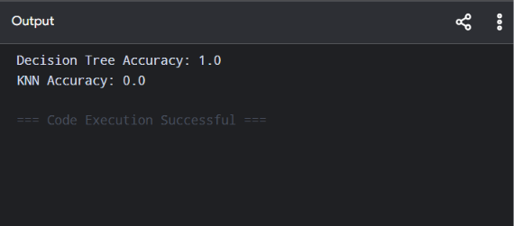

Dataset 3: Disease Diagnosis
This dataset provides clinical vital signs and medical metrics used to identify disease diagnosis outcomes.

Training Data
Temperature (°C) | Heart Rate (bpm) | Oxygen Level (%) | Disease
39.0 | 110 | 94 | Positive
38.5 | 108 | 95 | Positive
37.0 | 78 | 99 | Negative
39.2 | 115 | 93 | Positive
36.8 | 75 | 98 | Negative
38.8 | 112 | 94 | Positive
37.2 | 80 | 98 | Negative
39.1 | 114 | 92 | Positive
36.7 | 74 | 99 | Negative
38.9 | 111 | 93 | Positive

Target Variable: Disease (Positive / Negative)

New Sample for Prediction
Temperature (°C) | Heart Rate (bpm) | Oxygen Level (%)
38.7 | 109 | 94

PROGRAM

import numpy as np

X=np.array([[39,110,94],[38.5,108,95],[37,78,99],[39.2,115,93],
[36.8,75,98],[38.8,112,94],[37.2,80,98],[39.1,114,92],
[36.7,74,99],[38.9,111,93]])
y=np.array([1,1,0,1,0,1,0,1,0,1])

np.random.seed(42)
i=np.random.permutation(10)
tr,te=i[:7],i[7:]
Xtr,Xte,ytr,yte=X[tr],X[te],y[tr],y[te]

# KNN
p=[]
for x in Xte:
d=np.linalg.norm(Xtr-x,axis=1)
p.append(np.bincount(ytr[np.argsort(d)[:3]]).argmax())
knn=np.mean(np.array(p)==yte)

# Decision Tree
t=np.mean(Xtr[:,0])
p=(Xte[:,0]>=t).astype(int)
dt=np.mean(p==yte)

print("Decision Tree Accuracy:",dt)
print("KNN Accuracy:",knn)

OUTPUT

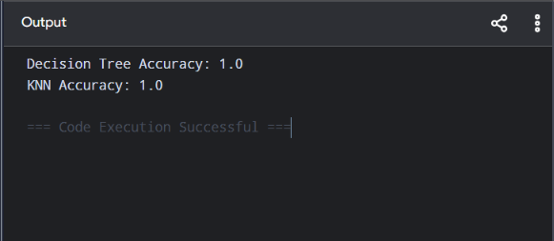

Dataset 4: Employee Promotion Prediction
This dataset tracks professional history and metrics used to determine employee promotion status.

Training Data
Experience (Years) | Performance Score | Training Hours | Promotion
10 | 95 | 50 | Promoted
8 | 90 | 45 | Promoted
7 | 88 | 40 | Promoted
3 | 65 | 20 | Not Promoted
2 | 60 | 18 | Not Promoted
9 | 93 | 48 | Promoted
4 | 70 | 25 | Not Promoted
8 | 89 | 42 | Promoted
2 | 58 | 15 | Not Promoted
6 | 85 | 38 | Promoted

Target Variable: Promotion (Promoted / Not Promoted)

New Sample for Prediction
Experience | Performance Score | Training Hours
7 | 90 | 44

PROGRAM

import numpy as np

X=np.array([[10,95,50],[8,90,45],[7,88,40],[3,65,20],[2,60,18],
[9,93,48],[4,70,25],[8,89,42],[2,58,15],[6,85,38]])
y=np.array([1,1,1,0,0,1,0,1,0,1])

np.random.seed(42)
i=np.random.permutation(10)
tr,te=i[:7],i[7:]
Xtr,Xte,ytr,yte=X[tr],X[te],y[tr],y[te]

# KNN
p=[]
for x in Xte:
d=np.linalg.norm(Xtr-x,axis=1)
p.append(np.bincount(ytr[np.argsort(d)[:3]]).argmax())
knn=np.mean(np.array(p)==yte)

# Decision Tree
t=np.mean(Xtr[:,0])
p=(Xte[:,0]>=t).astype(int)
dt=np.mean(p==yte)

print("Decision Tree Accuracy:",dt)
print("KNN Accuracy:",knn)

OUTPUT

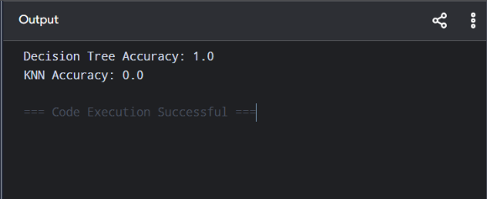

Dataset 5: Vehicle Type Classification
This dataset provides mechanical specifications and efficiency metrics used to distinguish between different vehicle categories.

Training Data
Engine Capacity (cc) | Weight (kg) | Mileage (km/L) | Vehicle Type
100 | 95 | 70 | Bike
125 | 110 | 65 | Bike
150 | 125 | 55 | Bike
800 | 850 | 22 | Car
1000 | 950 | 20 | Car
1200 | 1050 | 18 | Car
110 | 100 | 68 | Bike
900 | 900 | 21 | Car
140 | 120 | 58 | Bike
1300 | 1100 | 17 | Car

Target Variable: Vehicle Type (Bike / Car)

New Sample for Prediction
Engine Capacity | Weight | Mileage
135 | 118 | 60

PROGRAM

import numpy as np

X=np.array([[100,95,70],[125,110,65],[150,125,55],[800,850,22],
[1000,950,20],[1200,1050,18],[110,100,68],[900,900,21],
[140,120,58],[1300,1100,17]])
y=np.array([0,0,0,1,1,1,0,1,0,1])

np.random.seed(42)
i=np.random.permutation(10)
tr,te=i[:7],i[7:]
Xtr,Xte,ytr,yte=X[tr],X[te],y[tr],y[te]

# KNN
p=[]
for x in Xte:
d=np.linalg.norm(Xtr-x,axis=1)
p.append(np.bincount(ytr[np.argsort(d)[:3]]).argmax())
knn=np.mean(np.array(p)==yte)

# Decision Tree
t=np.mean(Xtr[:,0])
p=(Xte[:,0]>=t).astype(int)
dt=np.mean(p==yte)

print("Decision Tree Accuracy:",dt)
print("KNN Accuracy:",knn)

OUTPUT

